RETAILING

***Retailing can be defined as the activity we perform at Retailers level to generate information to make our presentation to the doctors more effective.***

***In other words, retailing is the art of collecting information from retailers and using this information effectively to make the sales call successful.***

***Before we proceed further, we must take into cognizance 3 aspects :***

*1.Who are Retailers*

*2.What is the importance of Retailers for MSR.*

*3.What information’s MSR collect from Retailers and How.*

**What are Retail Pharmacies?**

Retail pharmacists (often known as chemists or community pharmacists) supply and sell medicine and medical-related products to the general public and medical practitioners, as well as other goods such as toiletries, cosmetics.

**In the context of the Indian pharmaceutical industry, the supply chain side looks a little like this:**

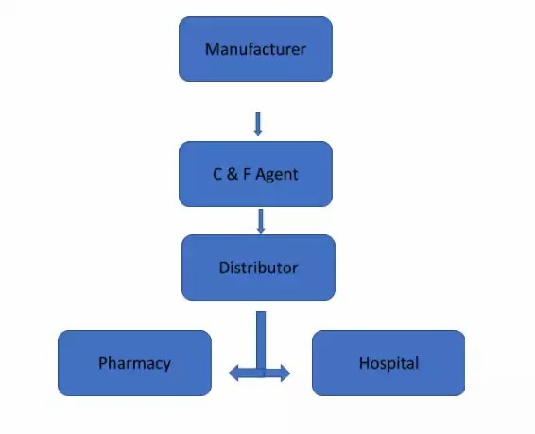

**Role and Importance of Retail Pharmacies :**

**Accessibility:**

Retail outlets provide essential access to medications for consumers, ranging from over-the-counter (OTC) products to prescription drugs.

**Consumer Engagement:**

Retailers can engage directly with consumers, offering counselling, medication management services, and health screenings, thus playing a critical role in public health.

**Marketing Channel:**

Retail environments serve as a marketing channel for pharmaceutical companies, particularly for OTC and consumer health products.

In-store displays, promotions, and pharmacist recommendations can influence consumer purchasing decisions.

To understand this process of Retailing well, we will discuss this topic under the following heads-

* Why there is a need to collect information from retailers?
* How to collect specific information from retailers?
* How to utilize the information for call planning?

1. ***Need to collect information from retailers:***

Pharmaceuticals selling is quite different from other types of selling .Let us see why it is so, with the help of following example:-

* A consumer sales representative selling to a super market Manager will know at the end of his interview/discussion whether he is getting a order or not.
* An Industrial Sales Representative selling to a Purchase Manager will know at the end of his interview/discussion whether he is getting a contract or not.
* An Insurance Sales Representative will be reasonably certain at the end of his interview whether the prospect will buy the policy or not.

***In all these instances, the Sales Representative in question will get to know the results/feedback of his sales interview right at the end of it,***

***But in case of Medical Sales Representative, we seldom gets to know the exact outcome of the sales call, because most doctors promise to prescribe but a few of them keep up to their promise,***

* ***How to collect “specific information”***
* ***What do you mean by “Specific Information”***

1. ***How to collect “specific information”***

Specific information means the quantified data of prescriptions received and products sold by the retailer within a specified time and who were doctors who contributed to the prescriptions and sales.

***Step 1- In this step we should decide on the details which we would like to follow up:***

Whether Dr.X prescribed product A

Whether Dr.Y prescribed product B

Whether Dr.Z prescribed product C

These types of questions are asked to find out whether doctors who gave specific commitments during our previous visit really kept up their promise

(This implies that we must know specific commitments obtained from doctors during our previous visits).

In fact the early part of our interview with retailer every time should be spent in verifying whether the doctor prescribed what they promised to prescribe. Since each retailer in the town will be catering to only three to four doctors we must seek for information only about these doctors from the retailer.

***Step 2***

***Deciding th product group or product about which we would like to collect information.***

* 1. One that is critical to our performance
  2. Or might be important to our areas team performance
  3. Or it might be important to our regions sales performance
  4. Or it could be that our competitor is doing so well with his product that we want a crack at him,

***Ideally we must choose an important product group every month to collect data on from our entire Territory*** . Such a specific effort will help us to create a fund or a bank of information that will help us to plan our work and to use our promotional materials effectively.

***Step 3***

* ***To collect purchase details of this product/ product group***. Just a day prior to our visit in a particular Town or territory, we should visit our stockiest to find out the details of purchases (of the product about which we are going to seek information) made by retailers. This step will help us to access ,the authenticity of information given to us by the retailer.
* Having prepared ourselves to visit the retailers to collect the information let us see how we have to proceed
* Proceed when we are face to face with the retailer.

The first part of our interview should be to find out the effect of our earlier visit. This is achieved by asking very direct questions

***The response will be yes or no***. If the response ***is YES,*** two more quwstions may be asked.

* ***How many prescriptions did you receive OR***
* ***How many STRIPS did you SELL.***

***Step 4***

***I***n the next part of the interview, our AIM should able to make the retailer speak about quantified data. For example-

* Which brand of Pain killers you mostly sell in your counter
* Which is the highest moving brand
* How many strip do you sell per day
* Who is the maximum prescriber of the brand.
* How many prescriptions do you get per day,

***C,How to Utilize the information for call planning:***

A mere collection of data from retailers will lead MSR nowhere. We shall have to process and analyse the information. For example

* Who are our major competitor
* Who are the doctors contributing to the sales of our product.
* Who are the doctors contributing to the sales of competitor’s product.
* How should I communicate to the concerned doctor.

***WE MUST REMEMBER THAT,VERY NATURE OF PHARMACEUTICAL BUSINESS IS DYNAMIC ,NOTHING REMAINS THE SAME IN THE MARKETPLACE FOR A LONG TIME.***

* ***New products are being introduced and old products are withdrawn or off focused.***
* ***New doctors come in the town ,***
* ***New companies/Divisions comes to the market.***
* ***Pricing changes in off patented products, etc.***

Retailers are vital to the success of NSR because they are the one who provide him with relevant business informations,It is unto the respective MSR to make use of retailer as an important business ally, who can keep us on the road to Success as an MSR.

***…………………………………………………………………………………………….***